K.R. MANGALAM UNIVERSITY

SCHOOL OF ENGINEERING AND TECHNOLOGY


OPERATING SYSTEMS: LAB ASSIGNMENT 3 COURSE CODE: ENCS351

SUBMISSION IN THE NAME OF: ADITYA SHARMA

ROLL NUMBER: 2301730275
COURSE: BTECH CSE (AI and ML) LINK TO GIT REPOSTORY:

Task 1: CPU Scheduling with Gantt Chart
Write a Python program to simulate Priority and Round Robin scheduling algorithms. Compute average waiting and turnaround times.
# Priority Scheduling Simulation processes = []
n = int(input("Enter number of processes: ")) for i in range(n):
bt = int(input(f"Enter Burst Time for P{i+1}: "))
pr = int(input(f"Enter Priority (lower number = higher priority) for P{i+1}: ")) processes.append((i+1, bt, pr))
processes.sort(key=lambda x: x[2]) wt = 0
total_wt = 0
total_tt = 0
print("\nPriority Scheduling:") print("PID\tBT\tPriority\tWT\tTAT") for pid, bt, pr in processes:
tat = wt + bt print(f"{pid}\t{bt}\t{pr}\t\t{wt}\t{tat}") total_wt += wt
total_tt += tat wt += bt
print(f"Average Waiting Time: {total_wt / n}")

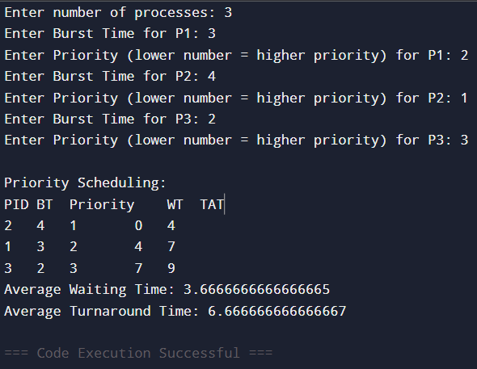
print(f"Average Turnaround Time: {total_tt / n}")
# Round Robin Scheduling Algorithm processes = []
n = int(input("Enter number of processes: ")) for i in range(n):
bt = int(input(f"Enter Burst Time for P{i+1}: ")) processes.append([i+1, bt])
quantum = int(input("Enter Time Quantum: ")) rem_bt = [p[1] for p in processes]
wt = [0] * n tat = [0] * n
t = 0 # current time
print("\nRound Robin Scheduling:") print("PID\tBT\tWT\tTAT")
while True: done = True
for i in range(n): if rem_bt[i] > 0:
done = False
if rem_bt[i] > quantum: t += quantum rem_bt[i] -= quantum

else:
t += rem_bt[i]
wt[i] = t - processes[i][1] rem_bt[i] = 0
if done: break
# Calculate TAT = WT + BT for i in range(n):
tat[i] = wt[i] + processes[i][1]
print(f"{processes[i][0]}\t{processes[i][1]}\t{wt[i]}\t{tat[i]}") print(f"Average Waiting Time: {sum(wt)/n}")
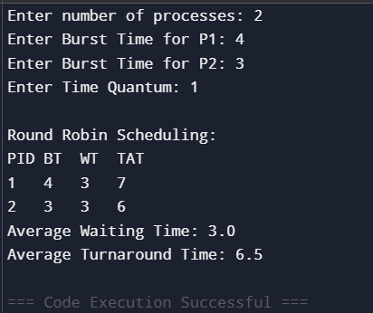
print(f"Average Turnaround Time: {sum(tat)/n}")
Task 2: Sequential File Allocation Write a Python program to simulate sequential file allocation strategy. total_blocks = int(input("Enter total number of blocks: "))
block_status = [0] * total_blocks
n = int(input("Enter number of files: ")) for i in range(n):
start = int(input(f"Enter starting block for file {i+1}: ")) length = int(input(f"Enter length of file {i+1}: ")) allocated = True
for j in range(start, start+length):
if j >= total_blocks or block_status[j] == 1:

allocated = False break
if allocated:
for j in range(start, start+length): block_status[j] = 1
print(f"File {i+1} allocated from block {start} to {start+length-1}") else:
print(f"File {i+1} cannot be allocated.")
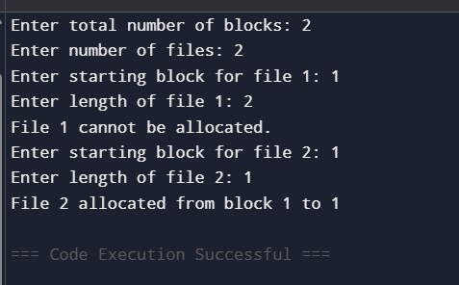
Task 3: Indexed File Allocation

Write a Python program to simulate indexed file allocation strategy.
total_blocks = int(input("Enter total number of blocks: ")) block_status = [0] * total_blocks
n = int(input("Enter number of files: ")) for i in range(n):
index = int(input(f"Enter index block for file {i+1}: ")) if block_status[index] == 1:
print("Index block already allocated.") continue
count = int(input("Enter number of data blocks: "))
data_blocks = list(map(int, input("Enter block numbers: ").split()))
if any(block_status[blk] == 1 for blk in data_blocks) or len(data_blocks) != count: print("Block(s) already allocated or invalid input.")
continue block_status[index] = 1 for blk in data_blocks:

block_status[blk] = 1
print(f"File {i+1} allocated with index block {index} -> {data_blocks}")
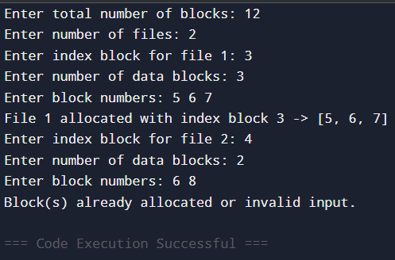

Task 4: Contiguous Memory Allocation Simulate Worst-fit, Best-fit, and First-fit memory allocation strategies. def allocate_memory(strategy):
partitions = list(map(int, input("Enter partition sizes: ").split())) processes = list(map(int, input("Enter process sizes: ").split())) allocation = [-1] * len(processes)

for i, psize in enumerate(processes): idx = -1
if strategy == "first":
for j, part in enumerate(partitions): if part >= psize:
idx = j break
elif strategy == "best": best_fit = float("inf")
for j, part in enumerate(partitions):
if part >= psize and part < best_fit: best_fit = part
idx = j
elif strategy == "worst": worst_fit = -1

for j, part in enumerate(partitions):
if part >= psize and part > worst_fit: worst_fit = part
idx = j if idx != -1:
allocation[i] = idx partitions[idx] -= psize

for i, a in enumerate(allocation): if a != -1:
print(f"Process {i+1} allocated in Partition {a+1}") else:
print(f"Process {i+1} cannot be allocated")

allocate_memory("first") allocate_memory("best") allocate_memory("worst")
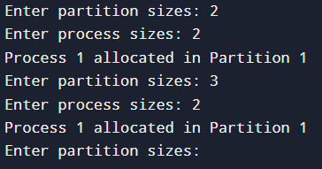

Task 5: MFT & MVT Memory Management
Implement MFT (fixed partitions) and MVT (variable partitions) strategies in Python.
def MFT():
mem_size = int(input("Enter total memory size: ")) part_size = int(input("Enter partition size: "))
n = int(input("Enter number of processes: ")) partitions = mem_size // part_size
print(f"Memory divided into {partitions} partitions") for i in range(n):

psize = int(input(f"Enter size of Process {i+1}: ")) if psize <= part_size:
print(f"Process {i+1} allocated.") else:
print(f"Process {i+1} too large for fixed partition.")

def MVT():
mem_size = int(input("Enter total memory size: ")) n = int(input("Enter number of processes: "))
for i in range(n):
psize = int(input(f"Enter size of Process {i+1}: ")) if psize <= mem_size:
print(f"Process {i+1} allocated.") mem_size -= psize
else:
print(f"Process {i+1} cannot be allocated. Not enough memory.")

print("MFT Simulation:") MFT()
print("\nMVT Simulation:") MVT()
